ImageJ Instructions for Plate Point Counts:

***All raw plate photos should be taken with the highest resolution possible. It is important to save an original photo and edit only a copy of the photo. This will allow you to refer back to the original photo when doing point counts if you need to “zoom in” on a specific organism for identification!***

- Rotate all plate images until straight before cropping. All plates should be rotated to be the same as all other plates in the time series (e.g. the top of the plate is always the same for the same plate). This can easily be done in the ‘Edit’ section of Apple ‘iPhoto’, ‘imagej’ or other photo software.

- Crop all plate pictures to the dimensions of the plate. All that should be remaining is the actual plate – nothing that overhangs the plate is counted. See pictures below for example.

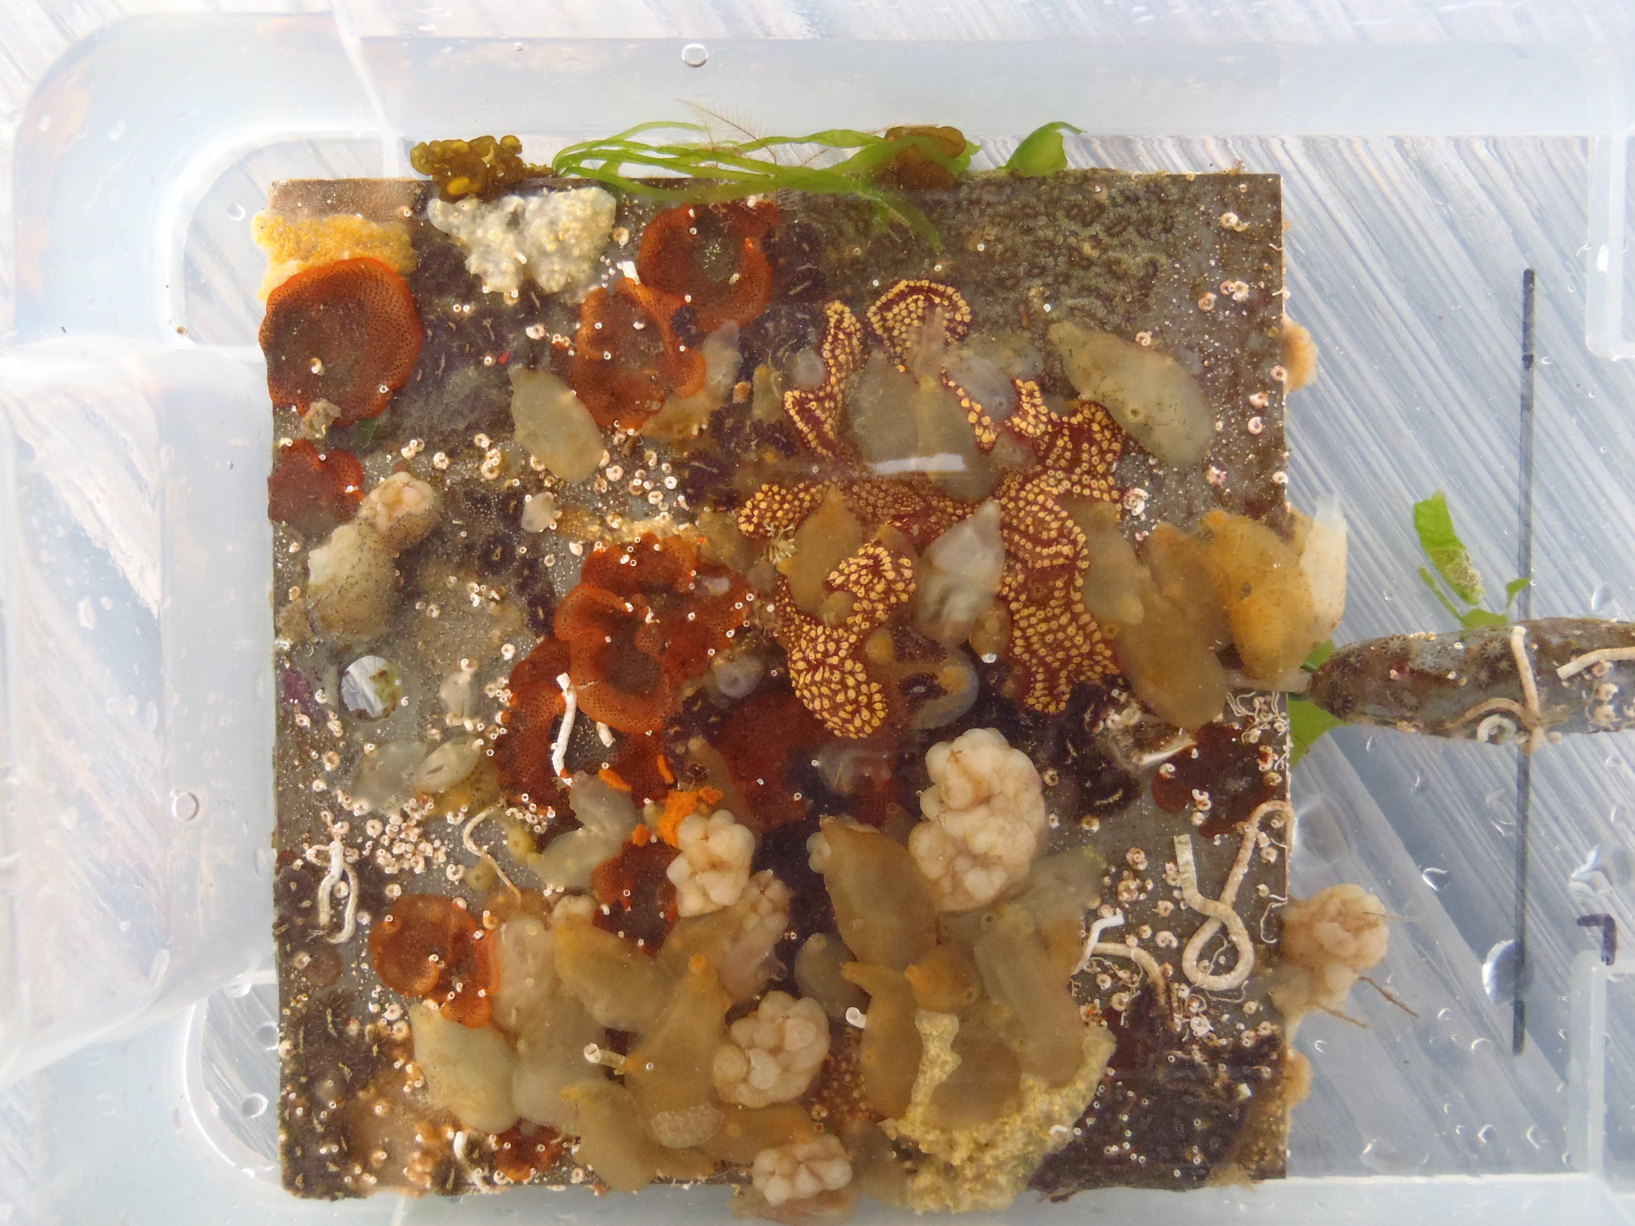
Before Cropping

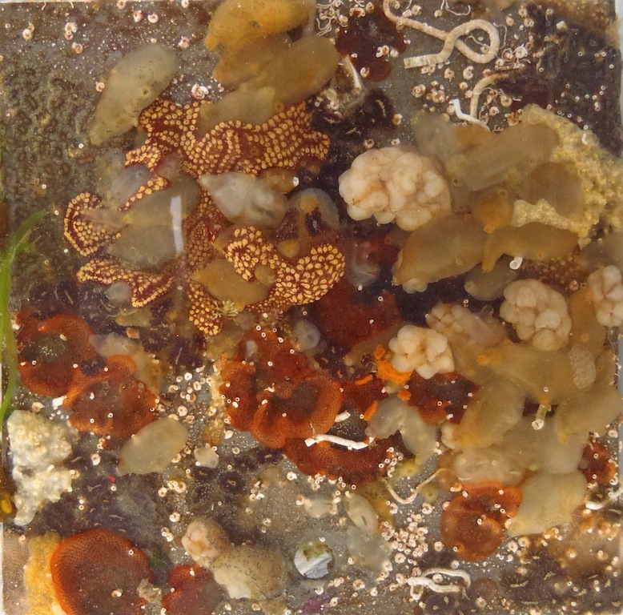
After Cropping

- Readjust the image size to approximately 1024 x 970 with ImageJ or 1024 x 768 pixels in Apple ‘Preview’ so that all images are of equal size and pixels. Also, make sure that the height and width are of equal size for every plate. This step is especially important if you are interested in following the change in specific colonies in a temporal study so that the ImageJ grid you overlay will have crosshairs that consistently fall in the same spot. The image size dimensions will be different, depending on what program you use to crop the picture, what camera is used and how close the picture is taken. Basically, you need to find a size that will allow you to capture the entire plate at approximately real size and overlay a 100 point count grid, but different years the photos are slightly different sizes and they may have used different cameras, so the key is just to pick a size where you can see things clearly and then be consistent, using the same size for all the plates.

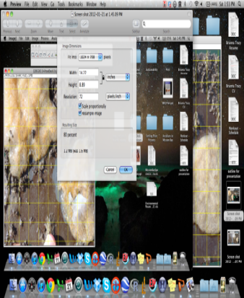

- Find ImageJ at: http://imagej.nih.gov/ij/index.html

- Download the software making sure that you have the correct version of java to run it.

- Open Plate Picture in ImageJ (File → Open… → [Image Location/Name])

- Overlay grid (Plugins → Analyze → Grid)

- Make sure ‘Area Point Count’ is at about 10000 (pixels) ^2 This should give you a 10 x 10 grid. Again, this will vary depending on the panel and camera, so if it doesn’t, adjust the number of pixels until it does. You should be able to see how many points are in the grid as you are making the adjustment, before you save it.

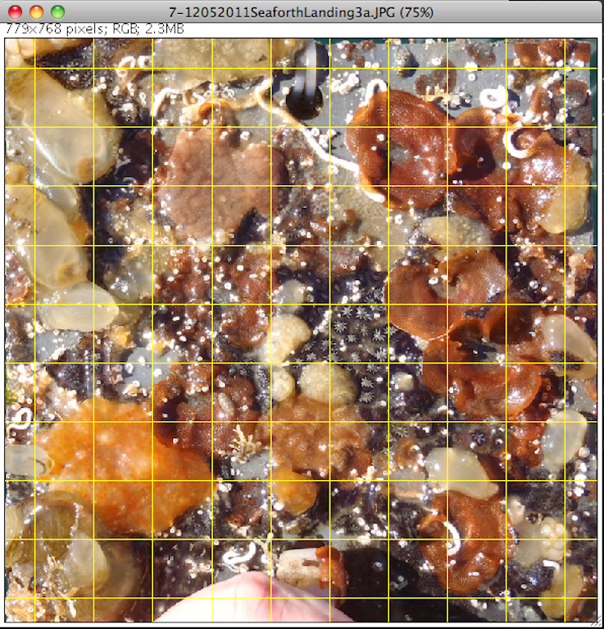

- Set grid type to ‘Crosses’ or ‘Points’ (I like crosses personally).

- Open the excel spread sheet and enter the codes for each taxa in the corresponding box of the spread sheet. The spread sheet is set up in a 10 x 10 grid to mimic the plate to make it simple to enter. Use species level names if possible, but you can use phyla level designations or if you don’t know use ‘UNK’. Fill in all of the squares, even the bare ones (there is a code for bare). You will automatically get a count of the number of points for each taxa. Since there are 100 points, that’s your percent cover!

